**Create table Commands**

create table user(username varchar(10) primary key,fname varchar(20),lname varchar(20),sex varchar(2),password varchar(10),phno varchar(10));

create table chat(chatid varchar(10)primary key,chatmsg varchar(100),chatdate varchar(20), senderuid varchar(10),receiveruid varchar(10));

create table broadcast(broadcastid varchar(10)primary key,message varchar(100),date varchar(20), sendername varchar(10),subject varchar(10),status varchar(20));

create table login(loginid varchar(10)primary key,loginusername varchar(20),loginpassword varchar(20), chatid references chat(chatid) on delete cascade,broadcastid references broadcast(broadcastid) on delete cascade);

create table department(departmentid varchar(10)primary key,departmentname varchar(20),username references user(username) on delete cascade,loginid references login(loginid) on delete cascade);

**Insert into commands**

insert into user values ('adbd','aditya','prabhu','m','adi69','435768');

insert into user values ('kd1','aabhiyanth','v','m','abhi69','436798');

insert into user values ('anviqd','anvitha','bhaskar','f','anvisrindu','237654');

insert into user values ('tlowju','theju','gowda','f','ilovedrama','562146');

insert into user values ('aryakun','arya','vijay','m','carslife','436969');

insert into chat values ('11','moshi moshi !','01-jan-2020','123','231');

insert into chat values ('12','hi !','05-feb-2020','456','341');

insert into chat values ('13','goodmorning','20-mar-2020','789','686');

insert into chat values ('14','ttyl','24-july-2020','124','789');

insert into chat values ('15','bye honey','30-dec-2020','125','691');

insert into broadcast values ('101','hey there','01-jan-2020','adbd','casual','200');

insert into broadcast values ('102','invitation','10-july-2020','kd1','formal','500');

insert into broadcast values ('103','ping','15-march-2020','anviqd','formal','200');

insert into broadcast values ('104','invitation','20-sept-2020','tlowju','casual','200');

insert into broadcast values ('105','invitation','24-nov-2020','aryakun','casual','200');

insert into Department values('21','new','adbd','701');

insert into Department values('22','frequent','kd1','702');

insert into Department values('23','old','anviqd','703');

insert into Department values('24','new','aryakun','704');

insert into Department values('25','frequent','kd1','705');

insert into login values('701','adbd','adi69','11','101');

insert into login values('702','kd1','abhi69','12','102');

insert into login values('703','anviqd','anvisrindu','13','103');

insert into login values('704','tlowju','ilovedrama','14','104');

insert into login values('705','aryakun','carslife','15','105');

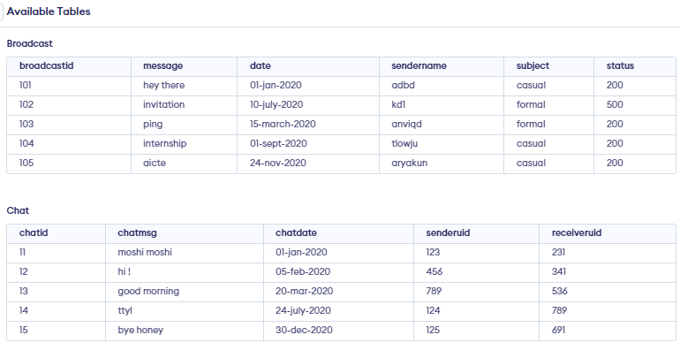

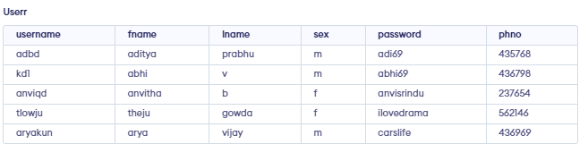

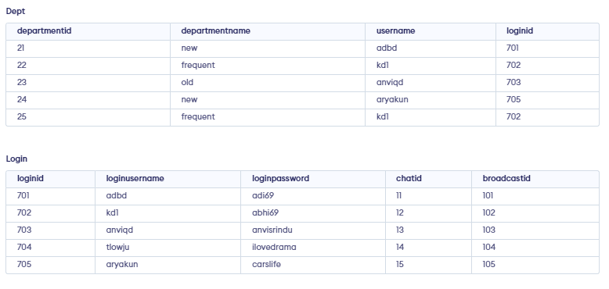

**QUERIES**

1) select username,fname,lname,sex,password,phno from userr u,broadcast b

where b.subject='casual' and u.username=b.sendername; 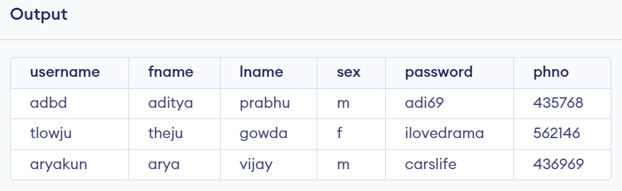

2) select DISTINCT c.chatid,c.chatmsg,c.chatdate,c.senderuid,c.receiveruid from chat c,login l, department d

where d.departmentname='new' and d.loginid= l.loginid ; 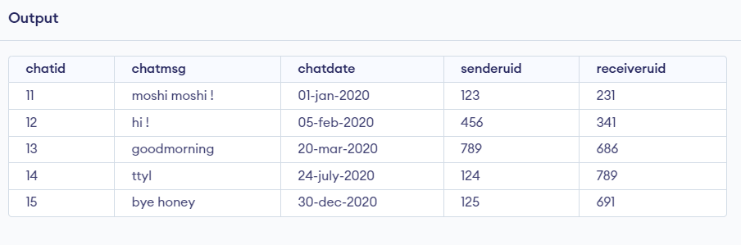

3) select chatid,chatmsg,chatdate from chat c

where chatdate > 20-mar-2020 ;

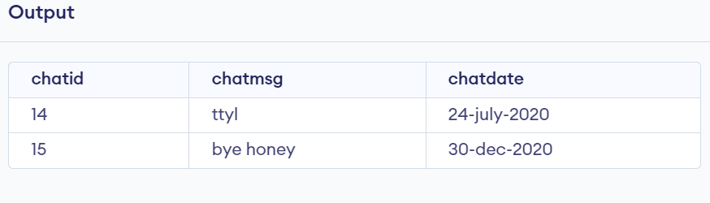

4) select c.chatid,c.chatmsg,c.chatdate from chat c,login l

where (SELECT SUBSTRING(loginusername, 1, 1) AS ExtractString from login)='a' and l.chatid=c.chatid;

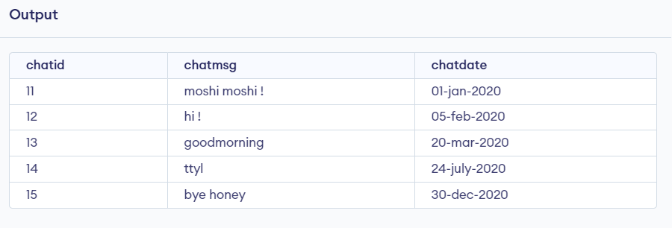

5) select DISTINCT u.username,u.fname,u.lname,u.sex,u.password,u.phno from user u,broadcast b

where b.subject='casual' or b.subject='formal' and b.sendername=u.username

